
Abingdon Works Centre
Autumn Leaves Run
Sunday 22nd October 2023

Starting and finishing just outside Abingdon, this leisurely 40-ish mile road run will travel through the Thames Valley countryside at a time when Mother Nature is often at her gloriously, colourful best. So why not join us and enjoy the Autumnal show in the company of fellow enthusiasts.

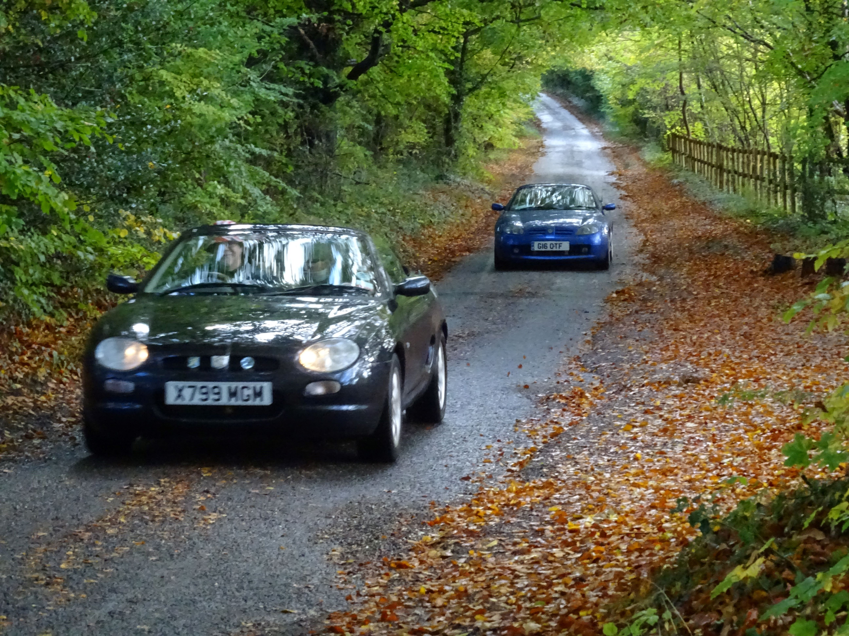
Cost £10.00 per car "+++++++++++++++++++++++++++++++++++++++++++++++++++++++++++++++++++++++++++++ "
Autumn Leaves Run 2023
Name : ……………………………………………………………..
Address : …………………………………………………………..
……………………………………………………………………...
……………………………………………………………………...
Postcode ………………
Tel: …………………………... Mobile:………………………...
E-mail: ……………………………………….
Car model:………………………………... Reg.No : …………..

Cheques payable to: MGCC Abingdon Works Centre or
BACS payment to: Sort Code: 20-01-09 Account No. 50620521
Account Name: MG Car Club Abingdon Works Centre
Reference: Autumn (+Surname)
Entries to Richard Martin, 26 Medlicott Drive, Abingdon, Oxon. OX14 5PS.
Tel: 01235 529331 e-mail: president@mgccawc.co.uk
If no e-mail address above, please include a stamped addressed envelope.

